Firewall
A Project Report Submitted
for
Information Technology
By
Nikhil Bhatt
(Roll no. 18)
Under the guidance of

Mr. Praveen Kumar Joshi

EVER GREEN SENIOR SECONDARY SCHOOL
(GOVERNED BY EDUCATIONAL WELFARE SOCIETY)
TULARAMPUR - 223139, DISTRICT-NAINITAL
UTTARAKHAND, INDIA
OCTOBER, 2021

CERTIFICATE

This is to certify that the project entitled “Firewall” being submitted to Evergreen Senior Secondary School, Haldwani for the project work of INFORMATION TECHNOLOGY is a record of the work carried by Nikhil Bhatt under my guidance and supervision.

Date: 08-Jan-2022 Supervisor
MR. PRAVEENJOSHI
Firewall
Ever Green Sr. Sec. School, Haldwani

Forwarded By:
MR. M.S. PARWAL
Principal
Ever Green Sr. Sec. School, Haldwani

Acknowledgments
I would like to express my most sincere heartfelt gratitude and respect to my supervisor PRAVEEN JOSHI, for suggesting the topic for my project work and for his excellent guidance, valuable suggestions and endless support throughout for preparing the report. I am greatly indebted to him for his constructive suggestions and criticism from time to time during the course of progress of my work.
I would like to express my gratitude and sincere thanks to Mr. M.S. Parwal, Principal of School, and entire faculty who has imparted considerable knowledge to me. Finally, I express my deepest gratitude to my parents for their continuous encouragement, understanding and support.

( Nikhil Bhatt )

INFORMATION TECHNOLOGY
TOPIC: - FIREWALLS
Table of Contents:-
- Introduction
- Background
- Perspectives
- Security
- Management
- Firewall Types
- Firewall Considerations
- Access Policy
- Closing ( Conclusion )

1- Introduction

1.1 Introduction of firewall in computer Network

- A firewall is a Network security device, either hardware or software device, which monitors all incoming and outgoing traffic and based on a defined set of security rules It accepts, rejects or drops that specific traffic.

- Accept:- Allow the Traffic.
- Reject:- Block the Traffic with an “ unreachable error “.
- Drop:- Block the traffic with no reply.

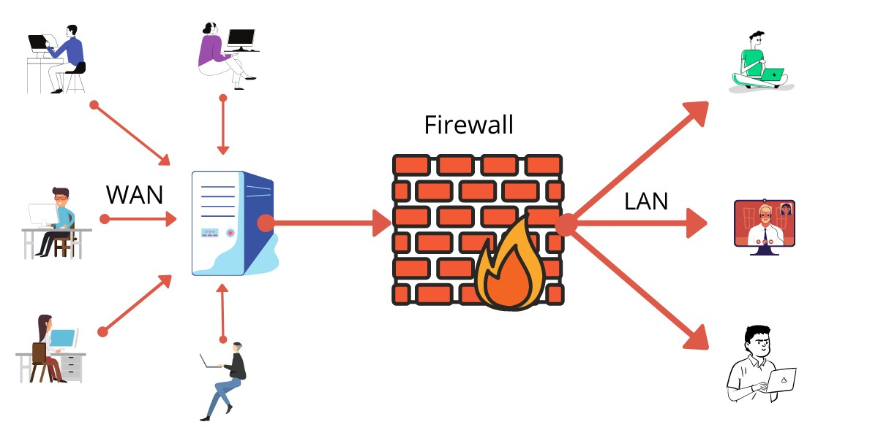
- A firewall Travels establishes a Barrier between secured internal networks and outside untreated network, such as the Internet.

Figure:-1 Introduction to firewall

- 2- Background:- Firewalls:- Hardware or software system used as an Initials checkpoint to prevent unauthorized Firewalls or malicious traffic from accessing a trusted network.

- Critical network component.
- Essential Layer of security.
- First Line of Defiance.

- Firewalls are like a traffic cop since they Define the Flow of communication and control which date is allowed.
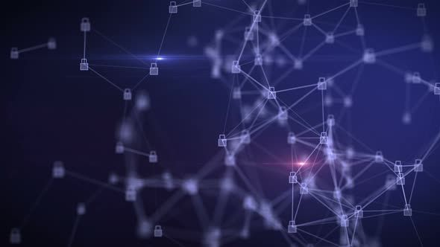
Figure:- 2 Network Firewall Background

- 3- Network traffic composes of :-

- TCP Packets
- UDP Data grams

- Packets are broken down into chunks for efficient routing across a network and then resembled when it reaches its destination.

3.1- TCP Packets more effectively filtered since more information is contained in TCP header than UDP header.

Firewall Security and Management Security & Management

4- Security:-

- Monitor all incoming and outgoing Traffic.
- Blocks traffic based on a defined set of security rules.
- Flag = No Go.
- Reduce or eliminate occurrence of unwanted packets.
- Audit and Lag network traffic.
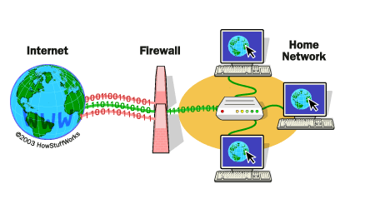
Figure:-3 Network Security Firewall.

5- Management

- Streaming what comes in and out of the Network.
- Control internet connection and File Types learning the network.
- Restrict access to certain sites.
- Security versus accessibility.
- Flexibility to control Data Flow.

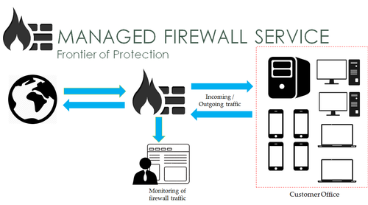
Figure:-4 Managed Firewall Service

6- Firewall Types

- Three main Firewall Types:-
- Stateful Inspection
- Packet Filtering
- Proxy

Stateful Inspection
Stateful Inspection Firewall

- Examined By group/ connection.
- Allows, Blocks, or Reject packets based on state, port and protocol. Every Interaction with the Network traffic is closely monitored until the connection is Terminated.
- The Firewall cheeks a Local State table determine if a connection has already been established, Requested, or a part of a previous connection.
- Stateful Inspection Looks at the series of packets and applies the rules to the Group gives its connection.
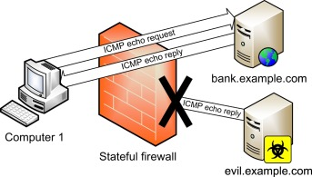
Figure:-5 Stateful Inspection Firewall

- PACKET FILTERING

- Examined Individually.
- Each Incoming and outgoing TP Packet Individually monitored without considering trends of other packets.
- Does not consider connection state and can only allow or deny packets based on Individual packet headers.
- Accepts or drops based on a specific set of rules defined form the firewall.
- Packets filtering can be configured in three ways:-
- Accept all safe packets, drop the Rest.
- Drop all unsafe, accept the Rest.
- Quarantine and query packets that do not have not have defined rules.
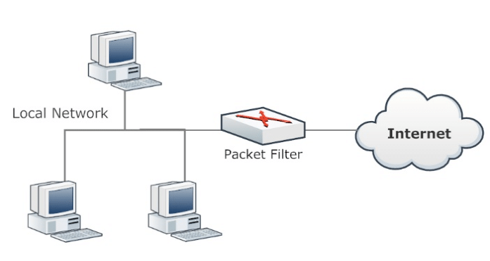
Figure:-6 Packet Filter Firewall.

- PROXY

- Examined Completely.
- Some capabilities as a Stateful Firewall, but analysis packet content beyond headers.
- Monitors from application layer to Expire additional signs of attack.
- Scalability and Network performance may be degraded due to the limitations and the need to have a proxy at each application level.
- Client opens a connection with the firewall and the firewall opens a Separate Connections to the Serva.
- Proxy firewalls perform as a middleman By Impersonating the recipient of the traffic and repackages information with same source address to destination host.
- With this connection, proxy firewalls can fully inspect and Make decisions based on Grandular Information Form the application layer.

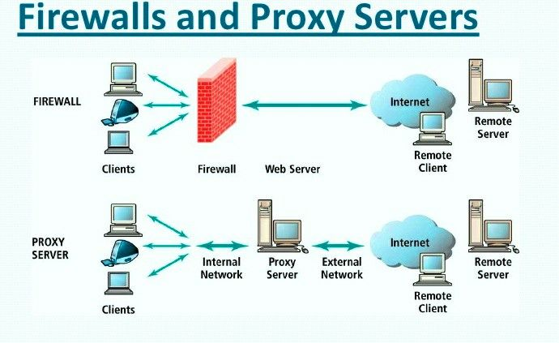
Figure:-7 Firewall and Proxy servers

- Firewall considerations

- Firewall Goals
- Fitting into Network Topology
- Defining Functionality
- Appliance or Software

- 7.1- Firewall Goals =>

- Understand organizational requirement of network security.
- Define certain objectives that the Organizations Wants to fulfill.
- Can security goals me be met by a simpler product rather than a robous Firewall?
- Outline Technical Goals relative to security and determine if a firewall can satisfy it Firewall?
- Outline Technical Goals relative to security and determine if a firewall can satisfy it.

Consider if it is worth investing on a full-feature firewall that is hard to administer.

- 7.2 Fitting into Network Topology

- An organization must know itself.
- The Network architecture must be properly understood to maximize efficiently and security. Firewall can be Placed at the :-

- Perimeter of the Network with an interface to the internet.
- Segment Between a sensitive Section of the Network and the remainder of the Network.
- Network Information such as traffic, connections to other systems, operating systems and performance must be well-throughout.

- 7.3 Defining Functionality

- Examine what you need carefully.
- Firewall functionality must be well-defined.
- Are the Requirements High Security with low throughout, or somewhere in between?
- Identify if it is appropriate to have :-

- Stateful inspection firewall.
- Packet filtering firewall.
- Proxy firewall
- Define what functionality and performance is needed to better prepare resource and understand what part of the network topology is affected.

- 7.4 Appliance or software

- Evaluate tradeoff between cost and efficiency.
- Hardware firewalls are easier to install by Plugging Eternal cabbies and performing basic network continuation.
- Hardware is more costly, but easier to manage with its own hardened operating system.

- 8 Access Policy ( Firewall )

- In network security it is critical to create a suitable firewall access policy.
- Do your due diligence and utilize that least privilege policy to that firewall rules and deny the rest.
- Only allow traffic defined by organization rules and deny the rest.
- Network administers added to should be keen in logging on all firewall policies.

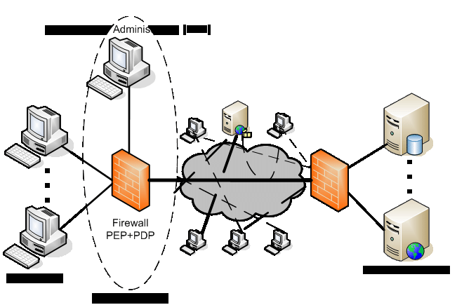
Figure:-8 Firewall Access Policy

- 9 CLOSING ( CONCLUSION )

- Firewalls

- Are Necessary to Ensure high Degree of Network protection and security.
- Cannot Guarantee 100% Security.
- First Line of Defense Against cyber Attacks.
- Critical Firewall Role in Securing.
- Network Communications.
- Consider Firewall Types and Features so Efficiency is maximized.
- Understand Tradeoff between Cost and accessibility.
- Plan access control Policies Cautiously.
- Although Firewalls cannot Do it all on their own, their capability to provide security within networks is imperative and will provide Peace of mind for many.
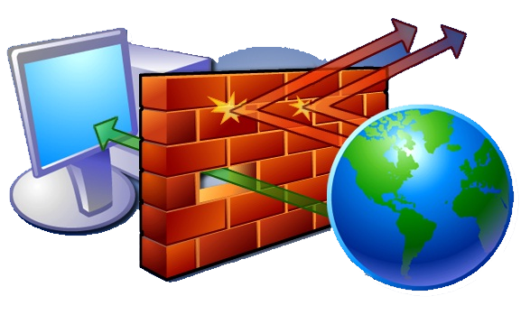
Thank You

